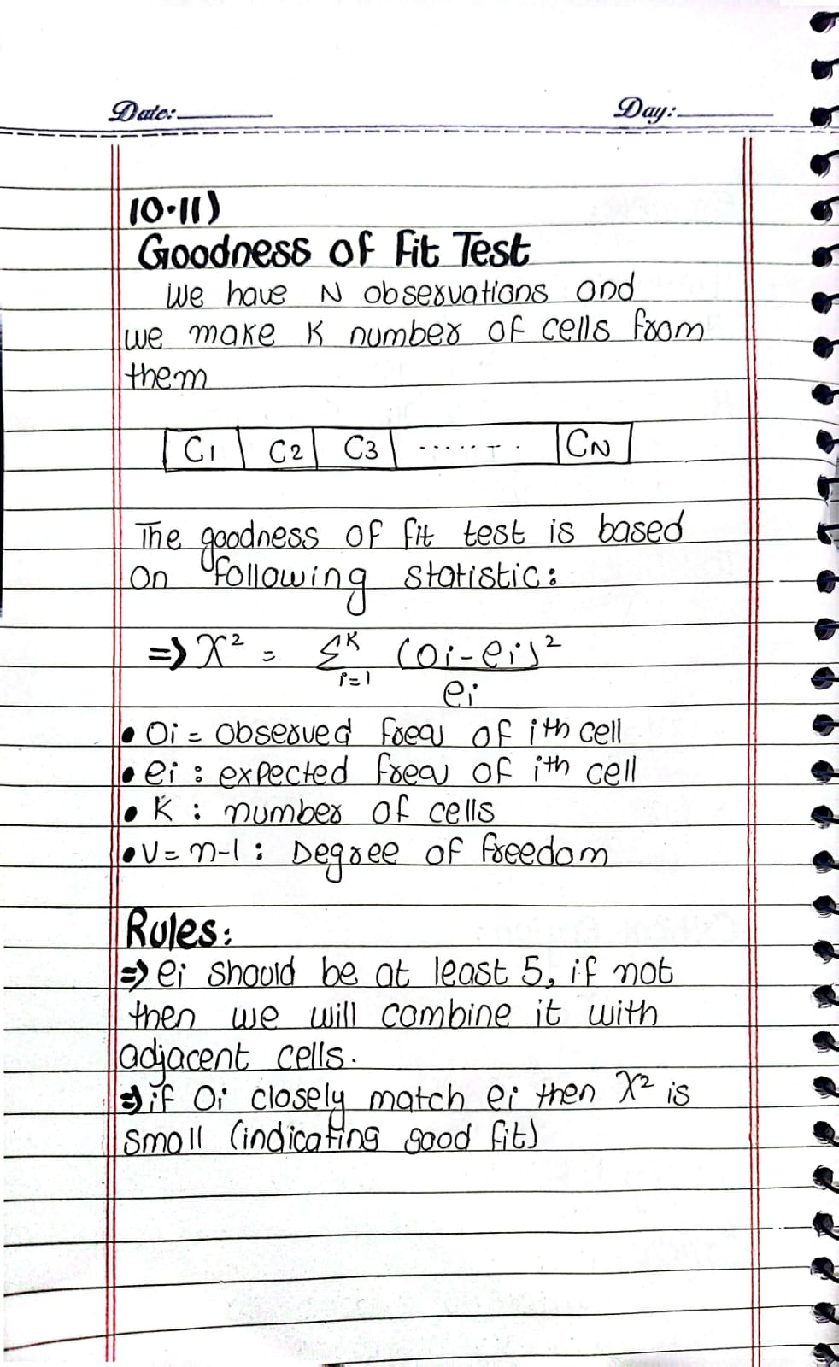

Question 1: Fairness of a Die
A six-sided die is rolled 120 times, and the observed outcomes are recorded in the following table: TEST GOODNESS OF FIT

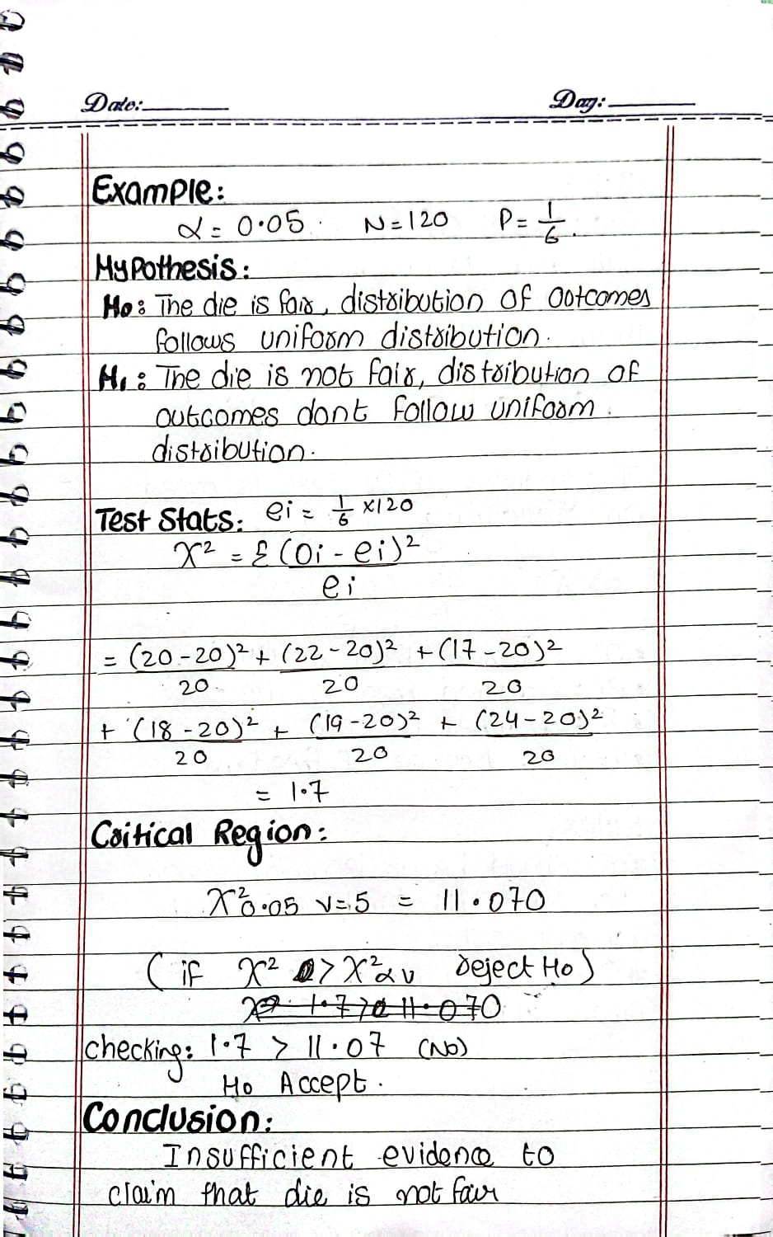

Question 2: Testing Normality of Battery Lives A manufacturer claims that the battery life of a certain brand follows a normal distribution with a mean of 3.5 hours and a standard deviation of 0.7 hours. A random sample of 40 batteries is tested, and the observed frequencies for different life ranges are recorded: TEST GOODNESS OF FIT
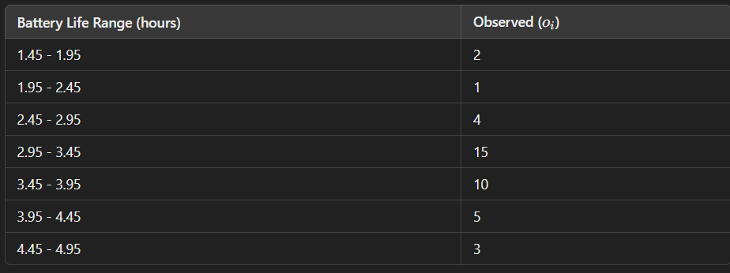
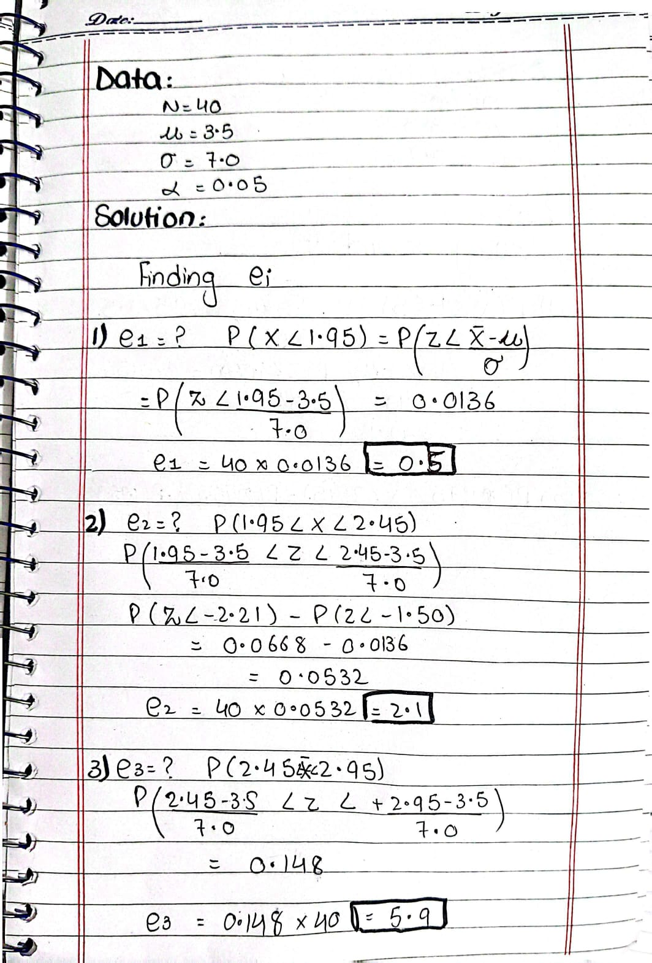

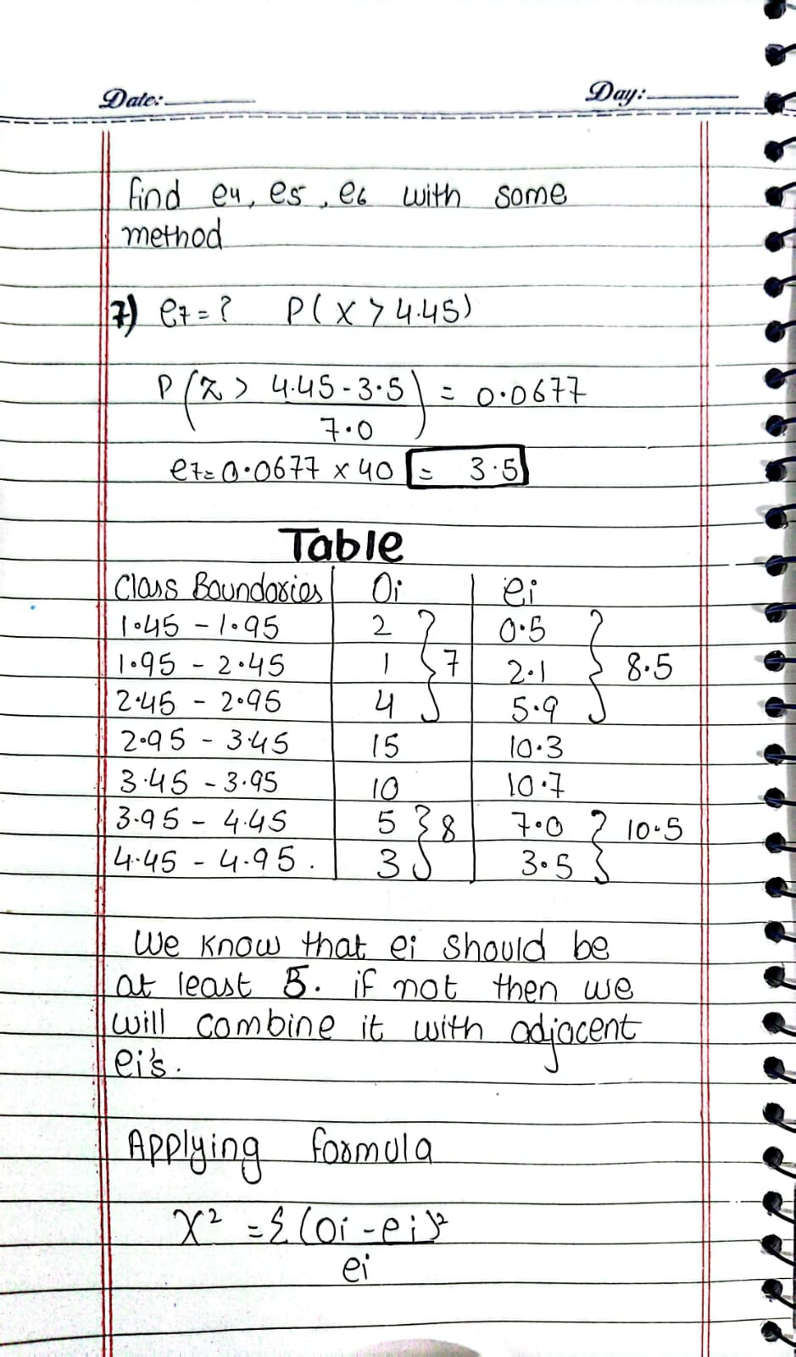

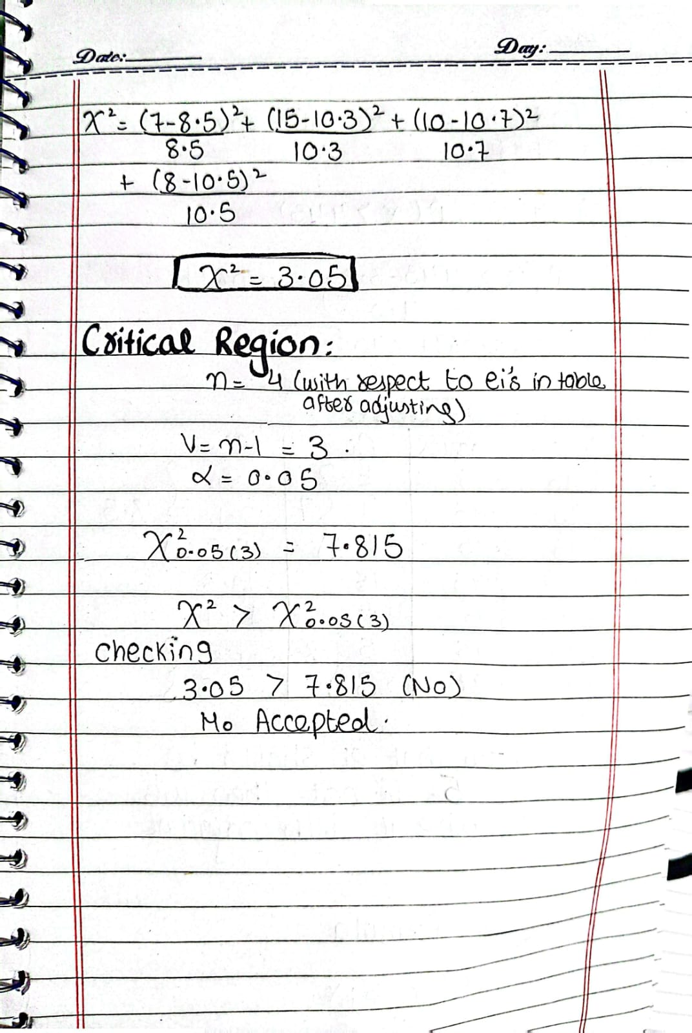

Question:
The following histogram was obtained by counting the occurrence of the first digits in telephone
numbers in one column of a telephone directory:
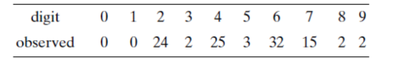
Test the goodness of fit of this data to a random variable that is uniformly distributed in
the set{0,1, ... ,9} at a 1% significance level.
